IMPETUS CORPORATION

EE 493 Design Studio 1

Business Statement Report

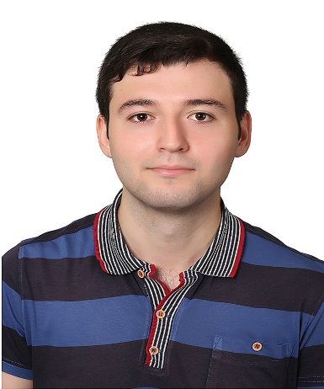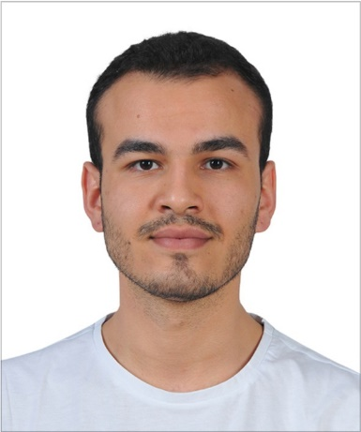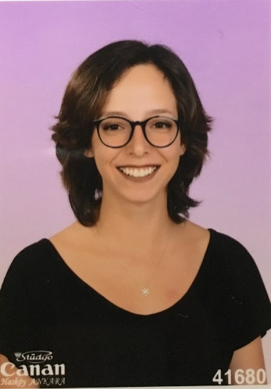

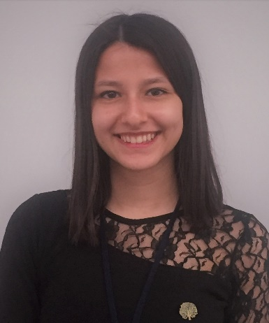

Elif Merve ÖZALP Emre Deniz ŞENEL Fahri TÜREDİ

2329746 2167237 2167435



Melike YILDIRIM Yunus YİLMAZ

2167591 2167658

Table of Contents

INTRODUCTION 3

VISION 3

MISSION 3

HUMAN RESOURCES 3

PROJECTS 3

CAT FEEDING 3

VALE PARKING 3

GIMME FAST 3

WHERE AM I? 3

CONCLUSION 3

APPENDICES 3

# INTRODUCTION

IMPETUS Corporation was established in September 2019 by five electrical and electronics engineering students at Middle East Technical University. The very first meeting of the company members took place at Çatı Cafe. The goal which brings the company members together is to produce intelligent solutions to everyday problems.The company pays attention to collect people from different fields of electrical and electronics engineering. The main specializations of the members are electronics, power electronics, and control. This field division among the members is expected to help the company to come up with distinguished approaches to various problems, as well as to create an opportunity for the members to work on their area of specialization.

# VISION

Following the guiding mind and science, our aim is to be an innovative and environmental-friendly technology company for a sustainable and livable world.

# MISSION

Primarily focusing on the needs of clients, to create innovative, reliable, time and energy efficient solutions in the field of electrical and electronics engineering.

# HUMAN RESOURCES

Since the very first gathering of the IMPETUS Corporation, diversity is an essential element of the company. Different ideas and various point of views are the keys of developing a strong culture. For this purpose, IMPETUS Corporation aims to gather experts from divergent specialization areas.

Elif Merve ÖZALP –Electronics Specialist

Specialized in electronics field. Her interests in semiconductor devices and quantum physics lead her to be in electronics division in IMPETUS Corporation.

Emre Deniz ŞENEL – Power Electronics Specialist

Specialized in power electronics and electromechanical energy conversion field. He feels enthusiastic about autonomous electric vehicles and motor drivers.

Fahri TÜREDİ – Electromechanical Systems Specialist

Specialized in electromechanical systems and design. His passion for Formula1 and electric vehicles fosters him to be a part of the IMPETUS Corporation.

Melike YILDIRIM – Control Systems Specialist

Specialized in control systems and bio robotics. Her interests mainly focus on bio-inspired intelligent machines and signal processing.

Yunus YİLMAZ – Computer and Communication Specialist

Specialized in computer systems and communication. His works on communication protocols and mobile applications lead him to be a computer specialist in IMPETUS Corporation.

# PROJECTS

## SMART CONNECTED CAT FEEDING SYSTEM

Smart connected cat feeding system is one of the projects that is assigned to EE493 students. The system must be autonomous, smart and refillable. The goal of the system is to overcome problems of manual feeding.

First of all, the system should feed only cats. If there are dogs in the feeding area, the system should distinguish and deter them from the area. The system should have a database which is some kind of feeding log. Thus, newcomers to feeding should be identified and recognized later by the system. Cats must be classified according to their weights so that different feeding regimes can be applied to them. Nothing can be attached to the animals. Because the same system can be used in different areas. Status of food supply should be observable via the internet.

The system is designed to make feeding easier. During the operation or charging, the battery level can be seen via the internet, too. So, it should be portable enough to be carried by a single person to charge it in case of a low battery. Battery should be non-removable and last for a minimum of 5 hours.

## VALE PARKING

## GIMME FAST

The project requires a system which can transfer complementary data packets via visible light communication. At the beginning, camera module will take a picture. Then, the picture will be divided into data packets of less than 10 kB . The transmission of the packets will be provided by visible light; that is, light-emitting diodes and photodiodes. First transmission will be done from the camera side to the vehicle side. The vehicle physically carries the data to the receiver side. Second transmission will be done from the vehicle to the receiver side. On the receiver side, the data packets will be reconstruct the picture and the picture will be displayed on a screen. There are some restrictions about the project as following:

* Maximum 8 LEDs and 8 photodiodes can be used in the system.
* The vehicle cannot approach terminals less than 5 cm.
* The vehicle must complete at least 5 full rounds to carry the whole picture.
* The transfer should be completed in less than 2 minutes.

According to the restrictions, both transmitter ends may contain 4 LEDs and both receiver ends may contain 4 photodiodes. These 4 pair can transmit 4 packets at the same time at different frequencies. Each photodiode should contain a band pass filter to reduce noise and discard possible received undesired packets. In order to increase the transmission speed, high frequencies can be selected according to LED’s and photodiodes properties. The vehicle should be fast enough to transmit the picture in five full rounds in two minutes.

The project requires a lot of information about the communication theory. The system needs a lot of optimizations. The algorithm behind the dividing the picture into packets and reconstruction of the picture from the packets should be consistent in each other.

## WHERE AM I?

In this project, our aim is to design and implement a remotely controlled vehicle that extracts physical and magnetic map and localizes itself.The game field including physical and magnetic landmarks is required to be identified by the vehicle. Afterward, the vehicle localizes itself and estimates the position based on the information ofthe extracted map. Therefore, there are two main parts for the project.

The first part is map extraction where the vehicle constructs the map of a game field. It is required to identify the position and send it wirelessly to vehicle by a camera which locates at a height of 1 meter outside of the game field. The physical landmarks, which are hidden identical rigids under the surface of game field and have hill-shape with maximum height of 5 cm and maximum diameter of 10 cm, will be detected by the sensors on vehicle. The surface material of the game field should be thin, plain and opaque sheet and allows landmarks to be detected. Whereas, the magnetic landmarks are different hidden cylindrical neodymium magnets under the surface. The game field has a rectangular shape with the size of 1.5m x 2.5m.There should be total number of 10 magnetic and physical landmarks at most. Computations for map-extracting should be done on the vehicle

Localization is the second part where using onboard sensors, vehicle finds its position and sends the information of location to a computer for visualization. The position estimation will not be carried out by the camera. At the end of localization, the accuracy of estimation needs to be compared with actual positions determined by the camera. As in the case of map extraction, both the physical and magnetic landmarks are used for this part. Vehicle should be free of camera and has an appropriate size which allows itself to fit inside a cylinder with a diameter of 20 cm. Localization operation needs to be carried out in minimum time with the highest accuracy.

# CONCLUSION

In this report, we introduced our company with its name, logo and members. The identity and personal information of the company members are presented on the cover page of the report together with their picture on top. Thereafter, we shared the mission and vision statements of our company, IMPETUS Corporation. Basically, IMPETUS’ vision is to contribute the sustainability and livability of the world by targeting the innovation and environmental-friendly technology to be its core values in the guidance of science and mind. The company puts bringing innovative, time and energy efficient solutions to its clients’ needs in the realm of electrical and electronics engineering as its mission. In the following Human Resources part, we described our company composition and division of field among the members. Before the gathering of the five members of the team, we thought that it would be key to the success of the company to have five people with diverse fields of interest and ability. Hence, we formed our company with people who has relatively complementary skills and interests. In fact, we decided on the field division inside the company in the Human Resources part by taking the specialization areas of the members into account. Finally, we provided the brief descriptions of each of the four projects. We tried to answer the questions of what is the problem stated in each of these projects and what is expected from us. In response to these questions, we explained the requirements and acknowledgements of each project. Furthermore, we added our thoughts about the projects suggesting possible solution methods and approaches.

# APPENDICES

**Elif Merve ÖZALP**

Undergraduate Senior Student of Electrical and Electronics Engineering of Middle East Technical University

Location: Ankara / Turkey

Telephone: +90 537 882 19 97

Email: [elif.ozalp@metu.edu.tr](mailto:elif.ozalp@metu.edu.tr)

Professional profile

I am a senior student in the Department of Electrical and Electronics Engineering of METU. My interests are electronics, solid state devices, semiconductors, and infrared sensors. I’m working on infrared sensors and semiconductor technologies as an undergraduate researcher. I want to be an academician and a qualified researcher.

Career Summary

**June 2019 – Present Quantum Devices and Nanophotonics Research Laboratory, Ankara**

**Undergraduate Researcher**

*Outline*

As an undergraduate researcher, my goal is to experience research environment and to be included on it before graduation.

*Key responsibilities*

* To obtain the necessary theoretical background.
* Processing thermal imaging sensors

**June 2019 – July 2019 ESEN System Integration, Ankara**

**Student Intern**

*Outline*

As a summer intern, my goal was to experience a workplace environment and use my theoretical background in industry.

*Key responsibilities*

* Implementation and testing UART module via Kintex KC-705 Evaluation Board and VHDL.
* Implementation and testing HDMI module via Kintex KC-705 Evaluation Board and VHDL.

**May 2018 – June 2019 CEMMETU, Ankara**

**Undergraduate Researcher**

Fullwave optimizations of nanoantenna arrays via MLFMA and Genetic Algorithms

**August 2018 – September 2018 Bozankaya Inc., Ankara**

**Student Intern**

*Outline*

As a summer intern, I’ve observed production and research-development stages of an electrical bus.

**September 2016 – August 2017 Hacettepe University Printed Circuit Board Laboratory, Ankara**

**Student Assistant**

*Key responsibilities*

* Manufacturing printed circuit boards (PCB) by using LPKF
* Manufacturing PCB’s by wet process

**April 2017 – August 2017 Hacettepe University Robotic Society, Ankara**

**Chairman**

**August 2016 – October 2016 POPEYES, Ankara**

**Cashier**

Education and qualifications

**April 2017 – Present Middle East Technical University, B.S.**

Electrical and Electronics Engineering

**August 2015 – August 2017 Hacettepe University, B.S.**

Electrical and Electronics Engineering (Until I transferred to METU)

Projects and Publications

**Pinball Game Design with Verilog**, METU EEE Logic Design Project, April 2019 – June 2019

**Wireless Communication System Design,** METU EEE Analog Design Project, April 2018 – February 2019

**Solar Tracking System Design,** METU EEE Circuit Laboratory Project, December 2017 – February 2018

Skills

* C Programming
* FPGA Programming with VHDL and Verilog
* Siemens NX

Hobbies

* Flute
* Pilates

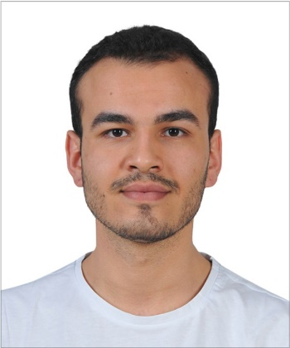**Emre Deniz ŞENEL**

Undergraduate Senior Student of Electrical & Electronics Engineering of Middle East Technical University

Location: Ankara / Turkey

Telephone: +90 539 587 02 18

E-mail: emre.senel@metu.edu.tr

Professional profile

After graduating from the high-school I became 749th in the university entrance exam (YGS-LYS) in Turkey in 2015. Currently, I am a senior student of Electrical & Electronics Engineering in METU. My interests are power electronics, electric vehicles and autonomous systems. Current, I am conducting two STAR EEE Projects in my university on induction machines and autonomous driving systems. My goal is to establish my own electrical autonomous vehicle brand.

Career Summary

**June 2019 – July 2019 ASELSAN Electronics Inc., Ankara**

**Student Intern**

*Outline*

As a summer intern, my goal was to observe defense industry and experience practical implementations of my theoretical background.

* Designed interfaces using MATLAB and GUIDE software.
* Analyzed intrinsic and extrinsic parameters of cameras.
* Implemented a simulation software of a camera.
* Analyzed different feature detection and feature extraction algorithms.
* Tested runtimes of different matching algorithms.

**July 2018 – September 2018 TOYOTA Motor Manufacturing Turkey, Sakarya**

**Student Intern**

*Outline*

TOYOTA’s manufacturing system is observed. Analyzed assembly division problems and conducted a symptom management project in maintenance engineering department.

* Controlled and observed the manufacturing process of the TOYOTA assembly factory.
* Joined to the meetings and observed how project management is done.
* Conducted a symptom management project which is a dust sensor.
* Joined Programmable Logic Controller tutorials and built a short-run code.

Education and Qualifications

* **Electrical & Electronics Engineering B.S,** Middle East Technical University, 2015 – Present (Currently Senior Student), CGPA 3.44/4.00
* **High School Graduate,** Gazi Anatolian High School, 2011 – 2015, Grade 93.06/100.00
* **Primary School Graduate,** Evrensel Primary School, 2004 – 2011

Projects and Publications

**Coordination of Autonomous Electrical Vehicles for Energy Efficient Driving**, METU EEE STAR Project, May 2019 - Present

**Induction Machine Test Setup Development**, METU EEE STAR Project, May 2019 – Present

**Pinball Game Design with VHDL**, METU EEE Logic Design Project, February 2019 – June 2019

**Wireless Communication System Design,** METU EEE Analog Design Project, September 2018 – February 2019

**Fire Alarm System Design**, METU EEE Circuit Laboratory Project, February 2018 – June 2018

**Solar Tracking System Design,** METU EEE Circuit Laboratory Project, September 2017 – February 2018

Organizations and Achievements

**Aegean Conference on Electrical Machines and Power Electronics (ACEMP)**, August 2019, Turkey – Organization Team Member

**BorusanAtölyeRobothon**, November 2019, Turkey – Winning Team Member

Skills

* MATLAB Programming
* C Programming
* MS Office
* Simulink
* VHDL Programming
* Leadership
* Teamwork

Languages

* **Turkish** - Fluent
* **English -** Advanced
* **French** – Elementary

Hobbies

* Chess
* Bass Guitar
* Formula 1
* Fitness

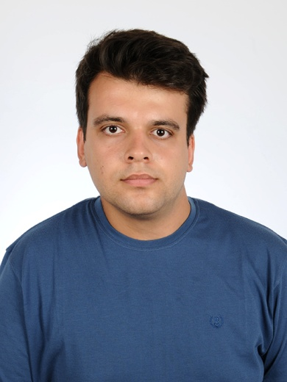**Yunus YİLMAZ**

Undergraduate Senior Student of Electrical and Electronics Engineering of Middle East Technical University

Location:Ankara / Turkey

Telephone: +90 537 506 54 79

Email: yilmaz.yunus_01@metu.edu.tr

Professional profile

I am Yunus Yilmaz, student in METU Electrical and Electronics Engineering and undergraduate researcher at CEMMETU.

Career Summary

**June 2019–July 2019 TAI - TUSAŞ, Ankara**

**Student Intern**

*Outline*

As a summer intern, my goal was to observe aerospace defenSe industry and experience practical implementations of my theoretical background.

*Key responsibilities*

* Designed AC-AC, AC-DC, DC-DC converters
* Designed switched power supplies
* Analyzed current mode control techniques
* Debugged VHDL designs

**August 2018 – September 2018 ELESTAŞ Electricity Production Inc. Eskişehir**

**Student Intern**

*Outline*

ELESTAŞ is a green energy company. The company builds only renewable energy centrals.

*Key responsibilities*

* The selection of cables that are going to use in the central
* Continuity of the production
* Principles of the inverters and productivity

**December 2017 – Present CEMMETU, Ankara**

**Undergraduate Researcher**

*Outline*

As undergraduate researcher, my role in the research group is designing composite structures and antennas according to required electromagnetic properties and testing designed structures by different algorithms.

Education and qualifications

* **Electrical and Electronics Engineering, 2,61/4 –** Middle East Technical University – 2020
* **High School, 91/100 –** Çanakkale Science High School– 2015
* **Primary School, 94/100 –** 75. Yıl Primary School – 2011

Publications and research

**Investigation of Waveguide Structures Using Surface Integral Equations,** CEMMETU (02/2018 – Present)

**Investigation of Layered Spherical Structures,** CEMMETU (10/2018 – Present)

**Pinball Game Design with Verilog HDL**, METU EEE Logic Design Project, February 2019 – June 2019

**Wireless Communication System Design,** METU EEE Analog Design Project, September 2018 – February 2019

**Fire Alarm System Design**, METU EEE Circuit Laboratory Project, February 2018 – June 2018

**Solar Tracking System Design,** METU EEE Circuit Laboratory Project, September 2017 – February 2018

Skills

* MATLAB Programming
* MS Office
* Simulink
* Verilog HDL Programming
* Teamwork
* Active Listening

Languages

* **Turkish** - Native
* **English -** Advanced
* **German** – Elementary

References available on request

* Özgür ERGÜL, Assoc.Prof. Middle East Technical University,Ankara

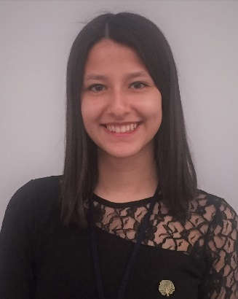**MELİKE YILDIRIM**

Undergraduate Senior Student of Electrical and Electronics Engineering at Middle East Technical University

Location: Ankara / Turkey

Telephone: +90 535 393 8743

Email: [melike.yildirim@metu.edu.tr](mailto:melike.yildirim@metu.edu.tr)

Professional profile

I am currently a Senior in Electrical and Electronics Engineering at Middle East Technical University with an interest in robotics, control theory and biomedical. Having an exemplary academic record along with an active involvement in a number of clubs and societies, I have a passion to pursue an academic career. With a high motivation and enthusiasm, I aspire to be the best version of myself.

Career Summary

**July 2019 – September 2019 Max Planck Institute for Intelligent Systems, Stuttgart, Germany**

**Research Intern**

I took part in two different bio-inspired robotic projects namely Inchworm Soft-Robot and Milli-Scale Soft-Bodied Robot in Physical Intelligence Department directed by Prof. Metin Sitti.

* Performed image processing algorithms with Python and OpenCV for robot detection
* Programmed a motor driver with Arduino Mega
* Calibrated 3D magnetic sensor and current sensor
* Used ROS platform for robot control
* Performed technical drawings on SolidWorks to build a small-scale soft robot on 3D printer and used laser cutter machine for millimetric-scale cutting
* Carried out numerous experiments for the projects and analyzed the data on MATLAB, EXCEL

**July 2018 – September 2018 Schneider Electric, Ankara, Turkey**

**Engineering Student Intern**

I gained experience in industrial automation systems, low voltage (LV) and medium voltage (MV) networks for electricity distribution-transmission systems.

* Constructed a single line diagram of a LV/MV electrical plant
* Programmed a PLC with ladder logic
* Gave a small presentation about methods of starting an induction motor

Education

**2015 – present Middle East Technical University, Ankara, Turkey**

B.S., Electrical and Electronics Engineering

GPA: 3.66/4.00, Expected graduation: June 2020

**2011 - 2015 Mersin Science High School, Mersin, Turkey**

GPA: 97.2/100,ranked 840th among 1.5 million students in the nationwide university entrance exam

Projects and Researches

* **Estimation of Complete Body Surface Potential Maps from a Limited Number of Measurements – Effects on Electrocardiographic Imaging,** METU EEE STAR Project, April 2019 – Present
* **Pinball Game Design with Verilog HDL**, METU EEE Digital Electronics Laboratory Project, February 2019 – June 2019
* **Optical Wireless Communication System: Photophone,** METU EEE Analog Electronics Laboratory Project, September 2018 – February 2019
* **Wireless Fire Detection System**, METU EEE Electronics Circuit Laboratory Project, February 2018 – June 2018
* **Single-Axis Solar Tracking System,** METU EEE Electrical Circuit Laboratory Project, September 2017 – February 2018

Activities

**2017 – 2018 IEEE METU Student Branch**

**Chair of Women in Engineering Project Group**

* Organized WIE TALKS, the first global event of IEEE TURKEY Women in Engineering Affinity Group, organized engineering-based technical trips, held meetings and conferences to highlight the importance of gender equality in engineering.

Volunteer

**Summer 2017 Work&Travel Program Student**

**Orleans, MA, USA**

* Worked as a cashier at Stop&Shop Supermarkets and as a bookstore clerk at Annie’s Bookstop for three months.
* Had opportunity to work in a culturally diverse environment and enriched personal skills.

**Summer 2016 Archaeology Volunteer**

**Jaen, Spain**

* Extracted archaeological elements, collected and recorded data with 25 volunteers from different countries.
* Gained international exposure and multicultural perspective.

Languages

* **Turkish**: Native Language
* **English**: Advanced Level
* **Spanish**: Beginner Level

Skills

* MATLAB, C, Python, OpenCV, Verilog HDL, ROS, MS Office, LTSpice, Kubotek KeyCreator